1. Two dogs pull horizontally on ropes attached to a post; the angle between the ropes is 60º. If dog A exerts a force of 270 N and dog B exerts a force of 300 N, find the magnitude of the resultant force and the angle it makes with dog A’s rope.

2. You walk into an elevator, step onto a scale, and push the “up” button. Your recall that that your normal weight is 625 N. Start answering each of the following questions by drawing a free-body diagram (a)If the elevator has an acceleration of magnitude 2.50 m/s², what does the scale read? (b) If you start holding 3.85-kg package by a light vertical string, what will be the tension in the string once the elevator starts accelerating?

3. Boxes A and B are in contact on a horizontal frictionless surface as shown in the figure. Box A has mass 20.0 kg and box B has mass 5.0 kg. A horizontal force of 100 N is exerted on box A. What is the magnitude of the force that box A exerts on box B?
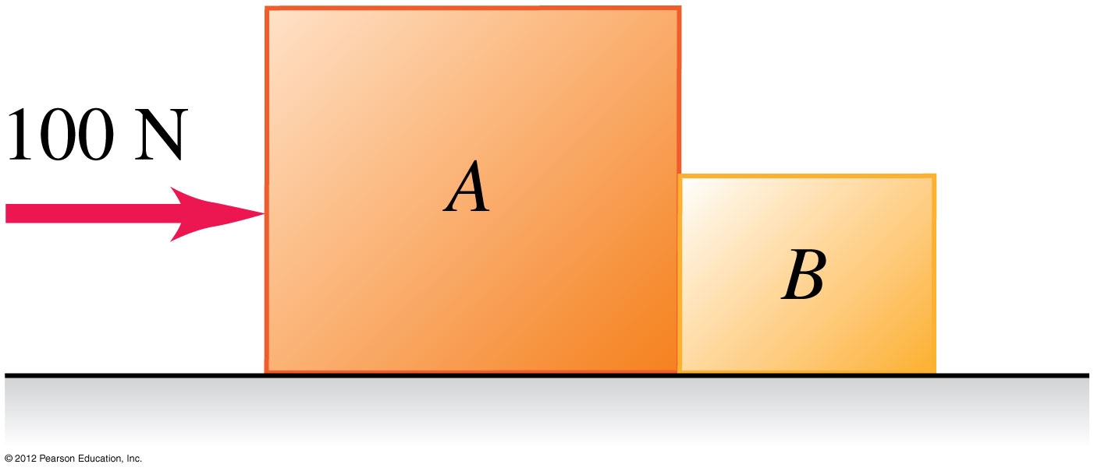

4. A bullet travelling at 350 m/s strikes a large tree which it penetrates to a depth of 0.130 m. The mass of the bullet is 1.80 g. Assume a constant retarding force. (a) How much time is required for the bullet to stop? (b) What force, in newtons, does the tree exert on the bullet?

5. The position of a helicopter (of weight 2.75 × 10⁵ N) is given by
r = (0.020 m/s³)t³ i + (2.2 m/s)t j – (0.060 m/s²)t² k. Find the net force on the helicopter at t = 5.0 s.

6. An object of mass m is at rest in equilibrium at the origin. At t = 0 a new force F(t) is applied that has components F_{x}(t) = k₁ + k₂y and F_{y}(t) = k₃t where k₁, k₂ and k₃ are constants. Calculate the position r(t) and velocity v(t) vectors as a function of time.

7. A light rope is attached to a block with mass 4.00 kg that rests on a frictionless horizontal surface. The horizontal rope passes over a frictionless mass less pulley and a block with mass m is suspended from the other end. When the blocks are released, the tension in the rope is 10.0 N. (a) Draw free-body diagrams for the blocks. (b) What is the acceleration for each of the blocks?(c) Find the mass m of the hanging block. (d) How does the tension compare to the weight of the hanging block?

8. A large crate with mass m rests on a horizontal floor. The coefficient of static and kinetic friction between the carte and the floor are µ_{s} and µ_{k} respectively. A woman pushes downward at an angle θ below the horizontal on the crate with a force F. (a) What magnitude of the force F is required to keep the crate moving at constant velocity? (b) If µ_{s} is greater than some critical value, the woman cannot start the crate moving no matter how hard she pushes. Calculate this critical value of µ_{s}.

9. A 50.0-kg stunt pilot who has been diving her airplane vertically pulls out of the dive
by changing her course to a circle in a vertical plane. (a) If the plane’s speed at the
lowest point of the circle is 95.0 m/s, what is the minimum radius of the circle for the
acceleration at this point not to exceed 4.00g? (b) What is the apparent weight of the
pilot at the lowest point of the pullout?

10. A bowling ball weighing 71.2 N is attached to the ceiling by a 3.8 m rope. The ball is
pulled to one side and released; it then swings back and forth as a pendulum. As the
rope swings through the vertical, the speed of the bowling ball is 4.20 m/s. (a) What is
the magnitude and direction of the acceleration of the ball at this instant? (b) What is
the tension in the rope at this instant?

Answers

1. 494 N, 31.8º
2. a) 784 N b) 47.4 N
3. 20 N
4. a) 7.43 × 10⁻⁴ s b) 848 N
5. (1.7 × 10⁴ N) i – (3.4 × 10³ N)k
6. 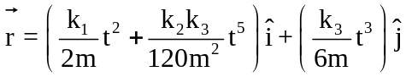 and 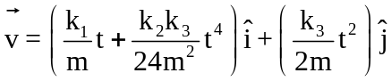
7. b) 2.50 m/s² c) m = 1.37 kg d) T = 0.75mg
8. a) F = µ_{k}mg/(cos θ - µ_{k} sin θ) b) µ_{s} = 1/ tan θ
9. a) R = 230 m b) 2450 N
10. a) a_{rad} = 4.64 m/s upward b) 105 N

